“Touching lives, improving life”

Procter & Gamble in Greater China

Founded in 1837, Procter & Gamble is one of the largest consumer products companies in the world. In fiscal year 2007, it had annual revenue of US$ 68.2 billion, and ranked 74th on Fortune 500 list of the world’s largest corporations.

P&G has operations in more than 80 countries, with more than 300 brands on market in 160 countries. These include Beauty, Household Care and Health and Well-being products. Three billion times a day, P&G brands touch the lives of people around the world.

P&G Greater China business includes Mainland China, Hong Kong and Taiwan, which were established in 1988, 1987 and 1985 respectively.

Procter & Gamble entered Mainland China in 1988 by establishing its first joint venture - P&G (Guangzhou) Ltd. Headquartered in Guangzhou, P&G China currently has operations in Guangzhou, Beijing, Shanghai, Chengdu, Tianjin, Dongguan and Nanping, and a technical center in Beijing.

In 20 yeas, P&G has made remarkable achievements in following areas:

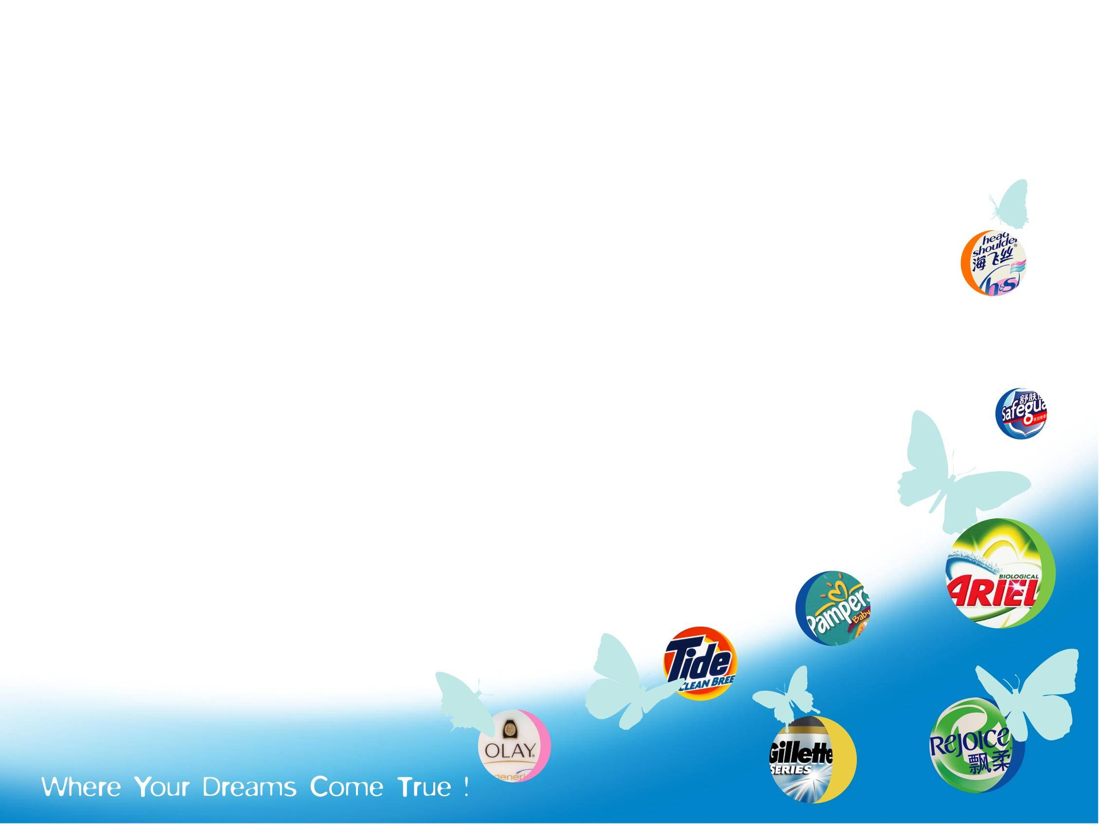
Building Leading Brands: P&G is the largest consumer products company in China. We are in No. 1 market share position in all categories where we compete. Rejoice, Safeguard, Olay, Pampers，Tide and Gillette are currently No.1 brands in China’s hair care, personal cleansing, skin care, baby care, powder detergent and male grooming category respectively.

Registering Strong Business Growth: P&G Greater China is one of the fastest growing markets in the world. It is at No.2 position in volume, and among the top 5 markets in value.

Building A Best-in-Class Organization: Together with company business growth, P&G’s China staff has grown rapidly. Over 97% of our Chinese workforce is made up by Chinese nationals. P&G China exports more managerial staff to other P&G markets than the other way around.

Committing to Being A Good Corporate Citizen: P&G has donated over 100 million yuan (US$10 million) to various charity causes in China, with Project Hope being the largest recipient of P&G corporate charity donations.

P&G Brands in China

Beauty: Rejoice, Pantene, Head & Shoulders, Vidal Sassoon, Clairol, Safeguard, Olay, SK-II, Whisper, Illume, Gillette, Braun
Household Care: Ariel, Tide, Pringles, Lenor, Pampers, Duracell
Health and Well-being Crest, Oral-B

Number of Employees Over 7,000

Total Investment Over US$ 1 billion

